
PRESS RELEASE Ostrava, 30 September 2015

Meeting of Mayor of the city of Ostrava and investors in Nová Karolina Park project

The Nová Karolina Park building was the site of a meeting and discussion between the Ostrava Mayor Tomáš Macura and Radim Passer, the Chairman of the Board of Directors of PASSERINVEST GROUP, a.s., and representatives of ABB s.r.o. and AXA Assistance CZ, s.r.o. The meeting reinforced and expanded the mutual cooperation between the city’s leaders and companies operating in Ostrava.

Ostrava’s Mayor Tomáš Macura met with Radim Passer, the Chairman of the Board of Directors of PASSERINVEST GROUP, Hannu Kasi, the President and Country Manager of ABB, Vladimír Kysela, the Director of the CEE Region for AXA Assistance, and Filip Chlebiš, the Regional Representative of Czechinvest.
The morning’s programme was a visit and tour of the spaces of ABB and AXA in the Nová Karolina Park building, including an introduction and presentation of both companies. There was also a discussion focussing primarily on the theme of mutual cooperation in the area of human resources and support for technical education and instruction in foreign languages.
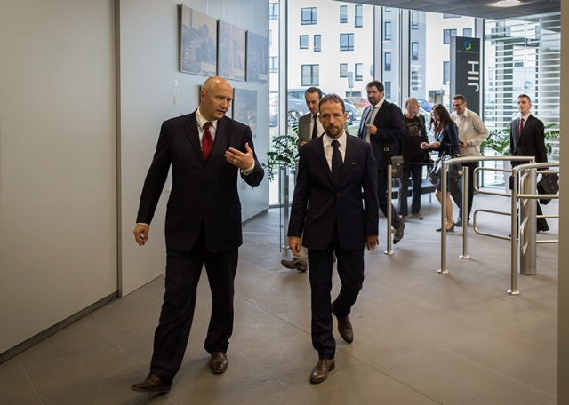
“I’m glad that this productive meeting with Mayor Macura and the representatives of the companies took place in our Nová Karolina Park project. Together we primarily discussed important issues concerning the lack of qualified human resources in the Ostrava region, which both of the companies are struggling with, and we discussed the possible mutual cooperation when looking for methods for supporting professional training. We also discussed the possibilities concerning potential investors for the Ostrava Region or the theme of transportation,” stated Radim Passer, the Chairman of the Board of Directors of PASSERINVEST GROUP, with regard to the meeting.

From left: Radim Passer, Chairman of the Board of Directors of PASSERINVEST GROUP during a tour of the Nová Karolina Park building with Tomáš Macura, the Mayor of the city of Ostrava and representatives of ABB and AXA Assistance
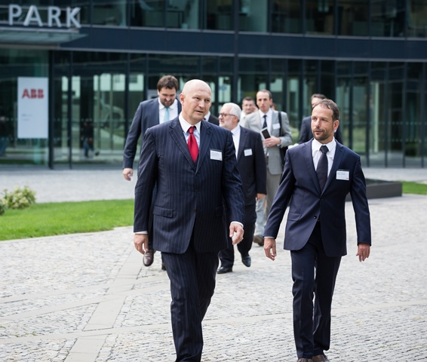
From left: Radim Passer, Chairman of the Board of Directors of PASSERINVEST GROUP during a tour of the Nová Karolina Park building with Tomáš Macura, the Mayor of the city of Ostrava and representatives of ABB and AXA Assistance

ABOUT THE NOVÁ KAROLINA PARK PROJECT
The Nová Karolina Park office building is sensitively located in a newly-urbanised area of Ostrava near Masarykovo náměstí and it forms a “gateway” from the historic core of the city. The developer of the project is a joint venture between PASSERINVEST GROUP and GEMO OLOMOUC. The project’s architectural design comes from the drawing boards of Vít Máslo and David R. Chisholm of CMC architects. The entire project is spread out over 32 hectares of space on six storeys and it offers almost 24,600 m² of prime office space. This is supplemented on the ground floor with 3700 m² of space suitable for shops, services and restaurants. There are 279 underground parking spaces meant for the users of the building. Nová Karolina Park is certified as a green building according to BREEAM (BRE Environmental Assessment Method). The British BREEAM certificate is a prestigious methodology for the certification of green buildings in Europe.

PASSERINVEST GROUP, a. s., is a purely Czech development company, whose name is primarily connected with the construction of the multifunctional BB Centrum complex in Prague 4 – Michle. The company, founded in 1991 by Radim Passer, built a very good name on both a domestic and international level with this, the most successful and extensive Czech project of its kind. This is not only due to the quality of the implemented projects and the high level of provided services, but also to a sense of fair play, an accommodating relationship with the tenants/users of the buildings and the responsibility towards society and the environment. PASSERINVEST GROUP also has other interesting development projects in its portfolio.

For more information and photographs in print quality please contact:
Mgr. Vendula Malochová, Marketing Manager
PASSERINVEST GROUP, a.s.
Tel.: (+420) 221 582 111, fax: (+420) 222 515 521
Mobile: (+420) 605 318 974
E-mail: vendula.malochova@passerinvest.cz
www.passerinvest.cz www.novakarolinapark.cz

Ing. Marcela Štefcová
Crest Communications a.s.
Tel.: (+420) 222 927 125
Mobile: (+420) 731 613 669
E-mail: marcela.stefcova@crestcom.cz
www.crestcom.cz

